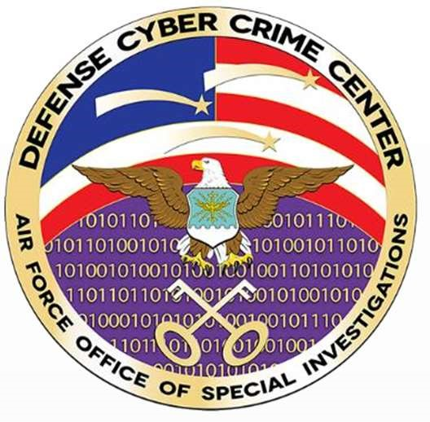

# Vmware Horizon Setup for Telework Employees

Source Directorate, BTO

06 April, 2021

# Logging into DEN Remote Desktop (via Horzion Client)

On your home/remote Windows/MAC OS system you will need to install the following software.

<https://my.vmware.com/en/web/vmware/downloads/info/slug/desktop_end_user_computing/vmware_horizon_clients/horizon_8>

After you install the client on your home system it will ask for a reboot.

After the reboot Double click on the VMware horizon client on your desktop below is what you should see.

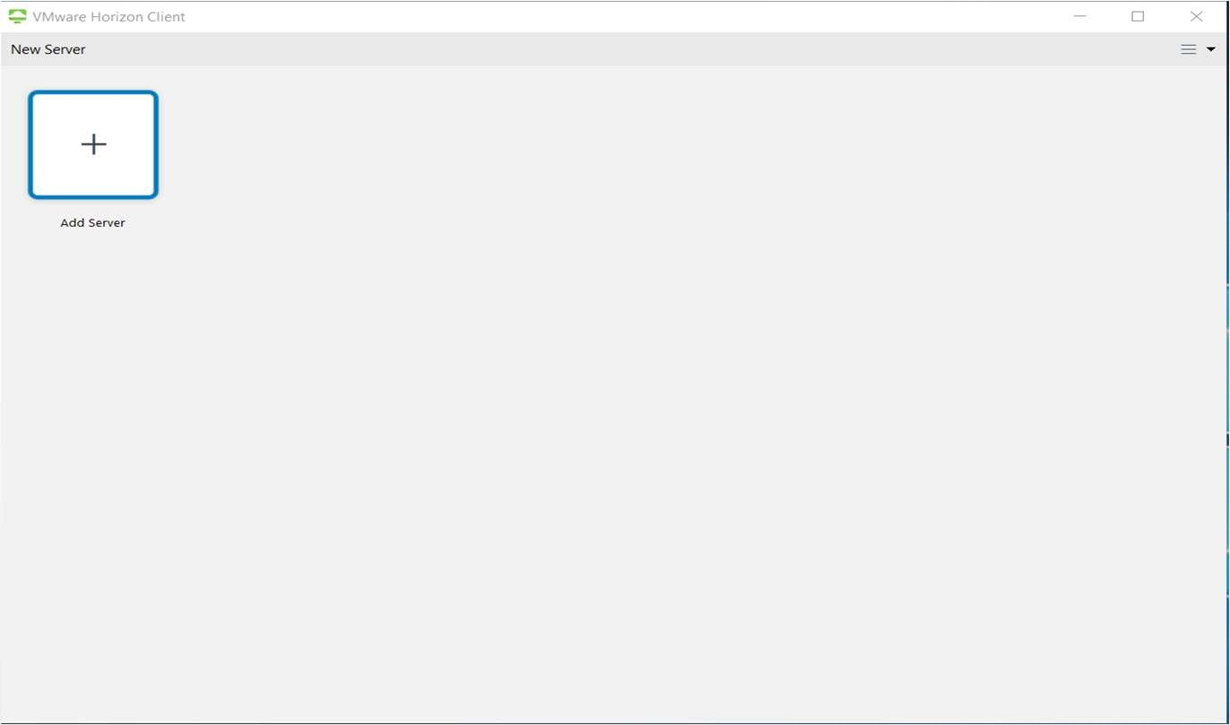

Within the Horizon client on the right side click the three bars and select configure SSL..

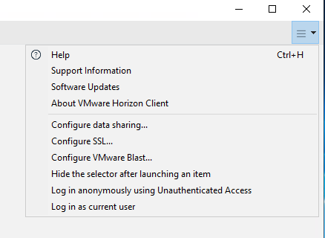

In the SSL Configuration menu select Warn before connection to untrusted servers and check the Allow connection via an SSL proxy. Click ok

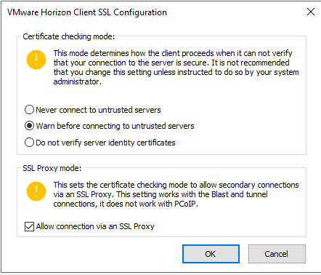

Click on the new server menu at the top and enter https://silverhawk.dc3.mil and click connect

Note: You will need to have the DOD certs installed on your home system for it to connect.

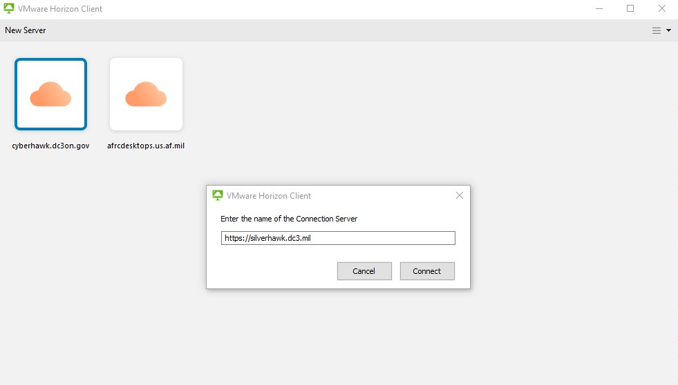

Click Accept on the warning banner

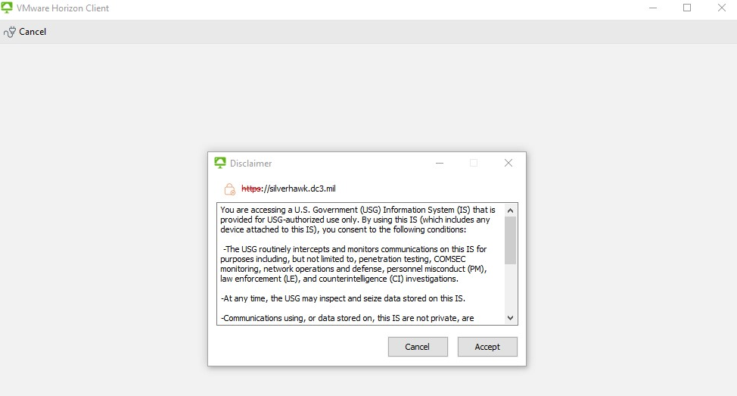

Select your piv certificate and select ok.

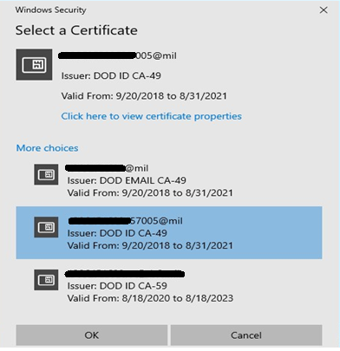

Enter your pin and click login

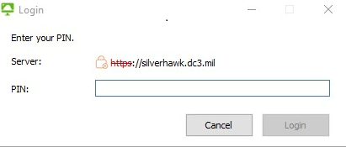

Double click the DC3 Instant Clone. There might be other desktops listed. These are special reason desktops. Users will know when to use them, don’t select these desktops if you aren’t given the ok to use them.

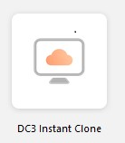

You should now be connect to your DEN desktop.

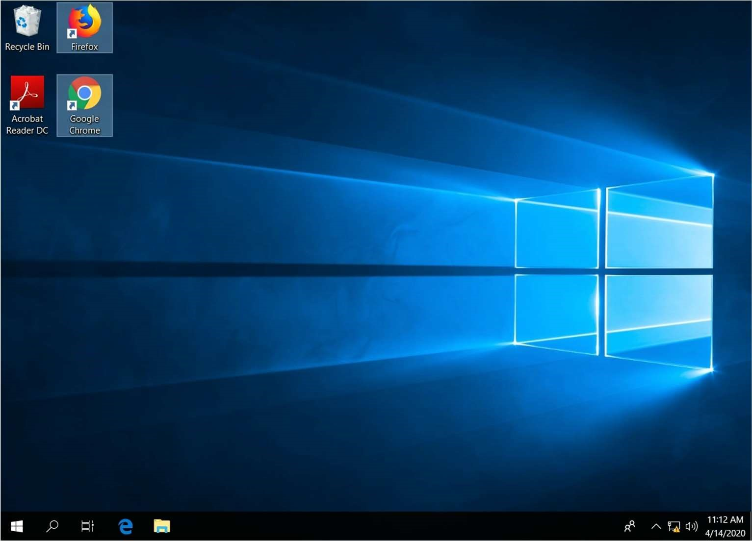

# 

Please call ITD Service Desk if you have any problems (410)981-1004